Shubhajit

Saha

**Mailing Address**

Ubisoft Entertainment India Pvt. Ltd.

Kumar Cerebrum, Building-3, Level-6

Kalyaninagar, Pune – 411006

**Phone**

+91-9970186882

**Email**

shubhajit.saha@ubisoft.com

shubhajit.saha@students.becs.ac.in

**Blog**

http://suvozit.blogspot.com/

Copyright 2012 © Shubhajit Saha. All Rights Reserved.

# Publications

S. Saha, G. Paul. **Ineffective Sharing of User Generated Content over Social Networking Sites**. *Submitted to CHI 2013*. Paris. 2013.

M. Agarwal, S. Saha. **Environment Educational Game Design**, *In the Proceedings of Grace Hopper Celebration of Women in Computing India*. Bangalore, India. 2011. [[PDF](http://sdrv.ms/SOzGSC)]

S. Saha, M. Agarwal. **Learning Chemistry through Puzzle Based Game: Atoms to Molecule**, *In the Proceedings of 9th IEEE International Conference on Emerging eLearning Technologies and Applications 2011*.StaraLesna, Slovakia. 2011. [[PDF](http://sdrv.ms/Ri9BfD)]

S. Saha, M. Agarwal. **Atooms to Moolecule (Game Design Abstract)**.*In the Proceedings of SPAC TRIGGER Vol. 24 Delhi Technological University (IEEE Student Branch)*. Delhi, India. 2011. [[PDF](http://sdrv.ms/SJsruw)]

# Projects

## Cops and Robbers with Multiplicity

*(Advisor: Goutam Paul)*

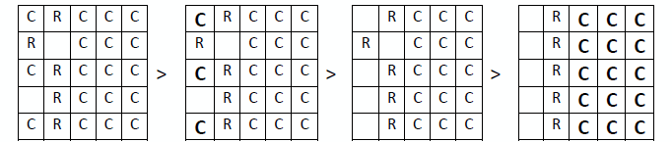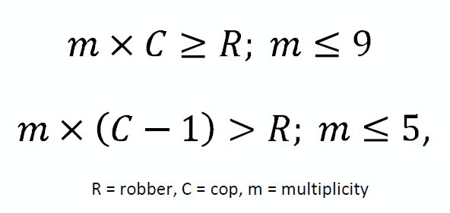Analyze the ‘cops and robber’ game with the modification to the game rule that even cops are venerable, multiple robbers are present and multiple cops can sit in a single grid. The objective was to find the multiplicity of the cops required to catch all the robbers, where multiplicity is the number of cops that can be placed in a single grid.

## Application of GIS in Rural Road and Habitation Mapping

*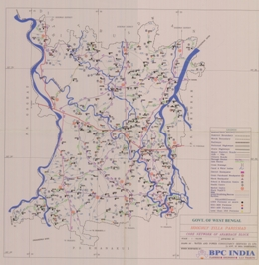Advisor: Prof. Sujata Biswas (Undergraduate Thesis, Bengal Engineering and Science University, Shibpur)*

The objective was to develop habitation database and rural road network database in block level, identify the unconnected habitation in the block and the growth center based on socio-economic parameters. It directly helps the villagers to upgrade living quality in terms of livelihood, medical, educational facilities.

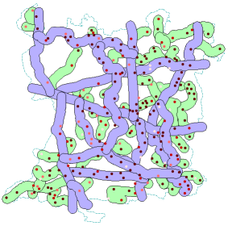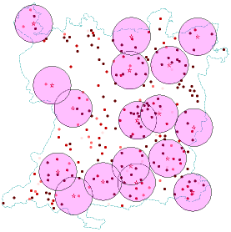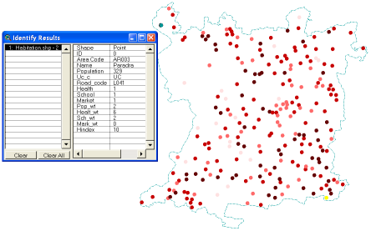

[[PDF](http://sdrv.ms/SJsruw)]

## Squares Vs Triangles

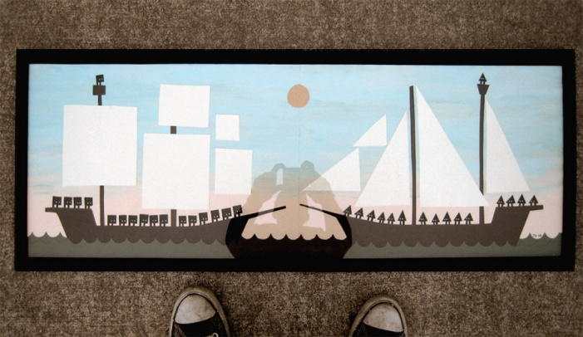A RTS game inspired from [Jon klassen's](http://www.burstofbeaden.com/) art [squarestrianglesatsea.jpg](http://www.burstofbeaden.com/squarestrianglesatsea.jpg) and [shapewarsweb2.jpg](http://www.burstofbeaden.com/shapewarsweb2.jpg). The objective is to reach the enemy (Triangle) Castle before they reach yours, Drag using LEFT mouse button to move any Square army. The game was developed for [Night and Day for November](http://experimentalgameplay.com/blog/2010/11/night-and-day-for-november/), an Experimental Gameplay Projects.

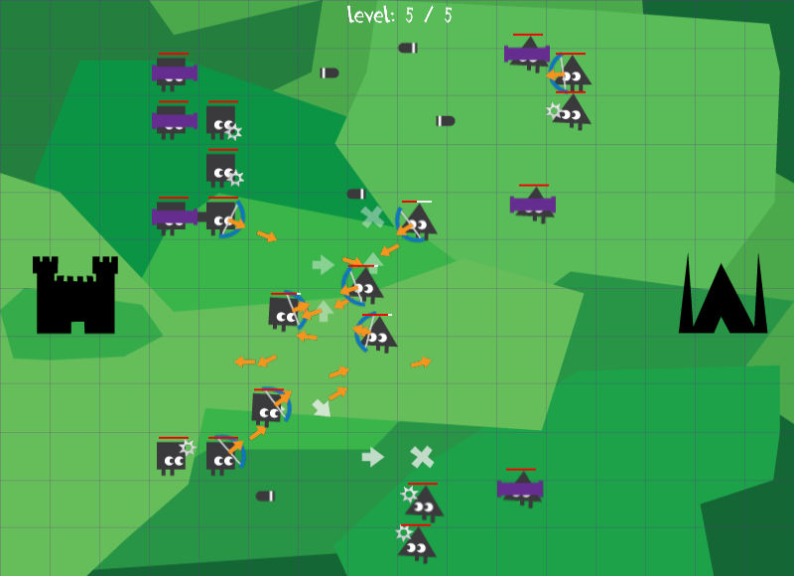[[Blog](http://bitsits.blogspot.com/2010/12/squares-vs-triangles.html), [Binary](https://docs.google.com/leaf?id=0B5zZbcACEiJlMGI1NGUwYWEtOGVmOS00YzdmLWFmZjQtYTQxYTg3ZWE4M2Ex&hl=en&authkey=CPf8xtIL), [Video](https://docs.google.com/leaf?id=0B5zZbcACEiJlMGI1NGUwYWEtOGVmOS00YzdmLWFmZjQtYTQxYTg3ZWE4M2Ex&hl=en&authkey=CPf8xtIL), [Windows Phone](http://www.windowsphone.com/en-US/apps/93c6c586-2773-e011-81d2-78e7d1fa76f8)]

## Atooms To Moolecules

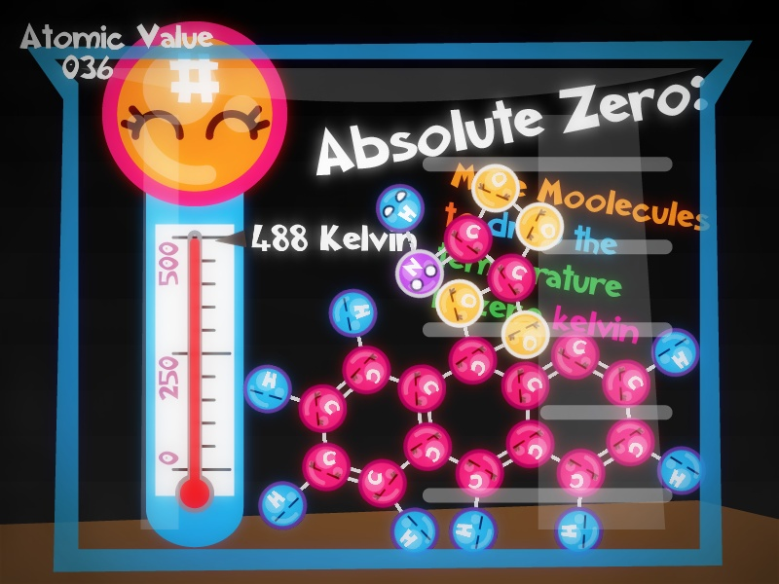A chemistry based puzzle game, drag and drop to connect the atomic creature and make molecules. The game also has a Lab Setup, a sand box mode where a player can setup a lab using different Equipment. The game was made as an [Independent Game Festival](http://igf.com/) 2011 entry. It won [Intel Level Up](http://software.intel.com/sites/campaigns/levelup2011/) 2011, Educational Category. The game demoed at [Electronic Entertainment Expo (E3)](http://www.e3expo.com/splash/) edition of Video Games Live and published on [Steam](http://store.steampowered.com/).

[[Blog](http://bitsits.blogspot.com/2011/02/atooms-to-moolecule.html), [Binary](https://docs.google.com/leaf?id=0B5zZbcACEiJlNjA4ODk4ZjgtYzM5NC00NWJmLTkxODItMzM1MTk0NGYxZmI0&authkey=CLa23roI&hl=en_US), [Video1](http://www.youtube.com/watch?v=Ddb_WVZlkZE), [Video2](http://www.youtube.com/watch?v=Ddb_WVZlkZE), [Windows Phone](http://www.windowsphone.com/en-US/apps/40dd71d3-fb57-4afb-9d44-95b24d57024d), [Steam](http://store.steampowered.com/app/213390/)]



## C:\Documents and Settings\suvozit\Desktop\push puzzle 3.pngPush Puzzle

A puzzle game where the player taps to slide the puzzle blocks in the correct order to their corresponding place to solve the puzzle. The game was my first experimental game prototype made in 4 days. This game was developed for [Experimental Gameplay Projects](http://experimentalgameplay.com/) - The April theme [Wash, Rinse, and REPEAT](http://experimentalgameplay.com/blog/2010/04/in-april-wash-rinse-and-repeat/).

[[Blog](http://suvozit.blogspot.com/2010/04/push-puzzle.html), [Binary](https://docs.google.com/leaf?id=0B5zZbcACEiJlZWFlYmMwMjQtN2Y2Ni00MDU0LTk4ZmYtYTg1YTE5ZjRhYTcz&sort=name&layout=list&pid=0B5zZbcACEiJlZTJmNzIwZDItMDg0YS00MDhlLWIzNDMtMDg1NjliYzI0Y2Fk&cindex=10), [Video](http://www.youtube.com/watch?v=n22Df-4jPH8), [Windows Phone](http://www.windowsphone.com/en-US/apps/df14a58e-935c-e011-854c-00237de2db9e)]

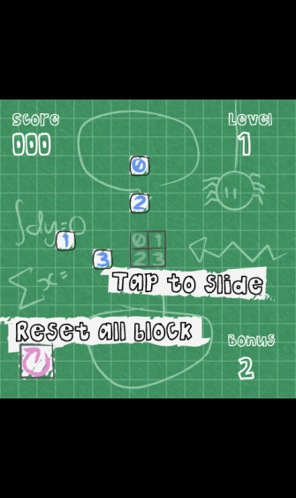

## C:\Users\shubhajit.saha\Desktop\Resume\Portfolio Data\BitSits%2520Games%2520logo-1.pngBitSits Framework

Microsoft® XNA and .NET based game engine developed for rapid prototyping. It runs on multiple platforms (Windows and Windows Phone 7). It also supports [Erin Catto’s Box2D physics engine](http://www.box2d.org/) under the [MIT License](http://www.opensource.org/licenses/mit-license.php).

[[Source VS2008](https://docs.google.com/viewer?a=v&pid=explorer&chrome=true&srcid=0B5zZbcACEiJlZTJlNzdmNDQtM2ViMi00NGMzLWE4MDQtNTBlYzNlNDc4MjJh&hl=en_US), [Source VS2010](https://docs.google.com/viewer?a=v&pid=explorer&chrome=true&srcid=0B5zZbcACEiJlYjUyMDdmMmItYmVkMC00MGRmLWI2ZGQtMmZlMDJkNGExMzcx&hl=en_US)]



## Gombli

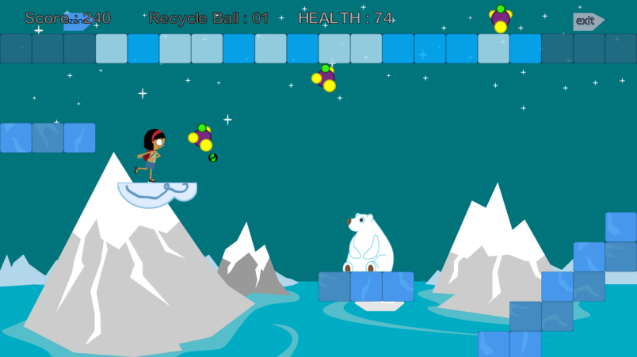A single player platformer game, the game character Gombli is an 11 year old girl. Gombli fights pollutants (Carbon dioxide and Chlorofluorocarbon) and solves puzzles on her quest. The obstacles in the game are Polar Bear and Penguin, to teach player that humans should not interfere with animal’s life. The game was made as an entry in Imagine Cup Game Design Competition 2010 Round 1. The [Imagine Cup](http://imaginecup.com/) 2010 Theme: “Imagine a world where technology helps solve the toughest problems”.

[[Blog](http://suvozit.blogspot.com/2010/03/gombli.html), [Binary](http://docs.google.com/leaf?id=0B5zZbcACEiJlMDhmYTQzZDAtNTQ5ZC00MjQ5LTkzYzMtM2JkMGYwY2M3MjNm&hl=en), [Video](http://www.youtube.com/watch?v=3JaXCBq9Ecw)]

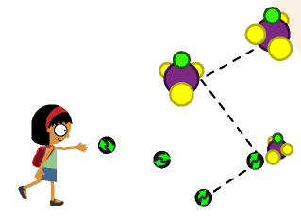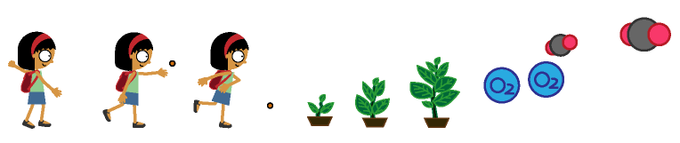

# C:\Documents and Settings\suvozit\Desktop\rubiks cube solver.PNGOther Prototypes

## Rubik’s Cube Solver

The solver uses Korf’s algorithm also called IDA*. The implementation is similar to Japp Scherphuis’s Cubie. The cube can be solved with a maximum depth of 25.

[[Blog](http://suvozit.blogspot.com/2011/06/rubiks-cube-solver.html), [Source and Binary](https://docs.google.com/leaf?id=0B5zZbcACEiJlZTUzMTE4ZDItYzRiMS00OTA1LTljNjQtM2JhZTY4ZWFlMTc2&hl=en_US&authkey=CJXWx90M)]

## C:\Documents and Settings\suvozit\Desktop\Sign Line Screenshot 5.pngSign Line

In the game player solves the puzzle by joining same kind of symbols. The player can join the symbols either linearly or by making loops. More Points are given to the player for making loops. The game was made as an entry in [Imagine Cup](http://imaginecup.com/) Game Design Competition 2011 Round 1.

[[Binary](https://docs.google.com/viewer?a=v&pid=explorer&chrome=true&srcid=0B5zZbcACEiJlOGFiNmU2NmQtZTQwNS00YmVlLTljNDgtNzVkY2IxMTFlODAw&hl=en_US), [Windows Phone](http://www.windowsphone.com/en-US/apps/b7b7f1fd-ca18-4030-8281-2f6a0eed63d0)]

## C:\Documents and Settings\suvozit\Desktop\Treasure Island1.pngTreasure Island

A game made in 48 hr made for [Ludum Dare #19 competition](http://www.ludumdare.com/compo/). In the game you collect as many treasure chest as you can and find the cross mark to go to the next level. To move to the next island use the boat. The game was also submitted in [Experimental Gameplay Projects](http://experimentalgameplay.com/) - [December DRAWING](http://experimentalgameplay.com/blog/2010/12/december-drawing/).

[[Blog](http://suvozit.blogspot.com/2010/12/treasure-island.html), [Binary](https://docs.google.com/leaf?id=0B5zZbcACEiJlZjY2YzJhMGYtODM5OS00MTdlLWFhZTItMjk2Njk5MGViYTFh&hl=en&authkey=CPLBqbwO), [Windows Phone](http://www.windowsphone.com/en-US/apps/8d73dd02-c8b7-4f52-8725-9394006a8333)]

## C:\Documents and Settings\suvozit\Desktop\Moolecule1.pngMoolecule

A game about connecting the atomic creatures to make bigger and bigger molecules. The game was developed for [Experimental Gameplay Projects](http://experimentalgameplay.com/) - [Two Months of CASUAL ADDICTION](http://experimentalgameplay.com/blog/2010/06/two-months-of-casual-addiction/) for June and July. It was further developed into Atooms to Moolecules.

[[Blog](http://suvozit.blogspot.com/2010/07/moolecule.html), [Binary](https://docs.google.com/leaf?id=0B5zZbcACEiJlYzdhNjkwZDktODgwNy00YWYwLTk4YWItM2VlZGIzZGNmNTFh&hl=en&authkey=CIrb268F)]

## C:\Documents and Settings\suvozit\Desktop\Apple e Apple2.pngApple e Apple

In the game you have to grow an apple tree and lots of apples before you collect all the arrows. The game was developed for [Experimental Gameplay Projects](http://experimentalgameplay.com/) - [Two Months of CASUAL ADDICTION](http://experimentalgameplay.com/blog/2010/06/two-months-of-casual-addiction/) for June and July.

[[Blog](http://bitsits.blogspot.com/2010/06/apple-e-apple.html), [Binary](http://docs.google.com/leaf?id=0B5zZbcACEiJlZjRlYWVlMDgtMmI0NC00YTU2LWExY2YtNDAzNTE4ZjQxZWZh&hl=en)]

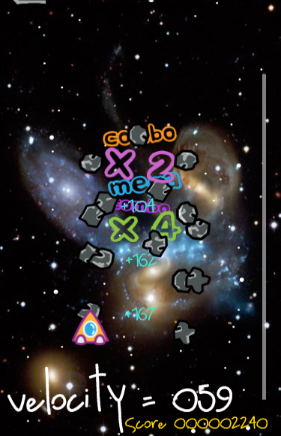

## Speedy Crash

Physics based game where you are trapped in an endless asteroid belt, where you crash into them using your velocity. Crashing into asteroids provides fuel. This game was developed for [Experimental Gameplay Projects](http://experimentalgameplay.com/) - The May theme [May means HIGH VELOCITY](http://experimentalgameplay.com/blog/2010/05/may-means-high-velocity/).

[[Blog](http://suvozit.blogspot.com/2010/05/speedy-crash.html), [Binary](http://bitsits.blogspot.com/2010/05/speedy-crash.html)]

# Awards and Achievements

* Atooms to Moolecules included in *NASSCOM GDC* USB Drive.
* Won *Intel Level Up 2011* in Educational Category.
* Published Atooms to Moolecules on *Steam* as a part of Intel Level Up Demo.
* Game Demo shown at *Electronic Entertainment Expo (E3)* edition of Video Games Live.
* Won Windows Phone 7 “*I Unlock Joy*” program in Student Category by Microsoft.
* Won “*Build Your Dreams with Windows Phone 7*” Applications contest – India 2011 by Microsoft.
* Certified and Published six games in *Windows Phone Marketplace*.
* First in GameX (Game Design Competition), *Tryst 2011* (IIT Delhi Techfest).
* Second in Demo Project *Tryst 2011* (IIT Delhi Techfest).
* Third in GameX (Game Design Competition), *Tryst 2011* (IIT Delhi Techfest).
* First in Envision, Ingenuity (Open Software Design), *Troika 2011* Delhi Technological University (IEEE Student Branch).
* Second in AppsDreamer *Synapse 2011* (DAIICT, Gandhinagar).
* First in OpenSoft *Kshitij 2011* (IIT Kharagpur Techfest).
* Second best prize in *BITM Eastern India Science and Engineering Fair*, with Undergraduate Scholarship for a year.
* Invited to compete in *INFOCOM (Kolkata)*, in Feb 2011.
* First in Software Designing *Bits2Bytes 2010* (BIT, Techno India).
* Rank of 192 (38th in India) during summer 2009, SPOJ. SPOJ has 250,000+ participants from 125 countries.
* 5th in Flawless *Edge 2009* (Techno India), where around 200 teams participated.
* Maximum *TopCoder* Rating of 1076 (Green member) during summer 2009.
* 1248th Rank in *WBJEE*. This exam is taken by all students in West Bengal for admission into engineering stream.
* State Rank of 732 in *AIEEE* .This exam is taken by around 500,000 students in India.

# Education

**Bachelor of Engineering in Civil Engineering**, Bengal Engineering and Science University, Shibpur.

*2007 to 2011, Percentage: 68.4% First Class*

*(Semester wise 71.9, 75.8, 66.9, 66.9, 69.7, 62.4, 67.7, 66.6)*

**Senior Secondary**, Indian School Certificate.

*2005 to 2007, Marias’ Day School, Howrah. Percentage: 86.6%*

**Secondary Education**, Indian Council of Secondary Examination.

*1995 to 2005, St. Aloysious’ Orphanage and Day School, Howrah. Percentage: 78.4%*

# References

**Dr. Goutam Paul**

Asst. Professor, Computer Science & Engineering

Jadavpur University, Kolkata – 700 032.

E-mail: goutam.paul@ieee.org

**Dr. Sujata Biswas**

Professor, Civil Engineering

Bengal Engineering and Science University.

E-mail: sujata@civil.becs.ac.in

**Dr. Kalyan Kumar Bhar**

Professor & Head, Civil Engineering

Bengal Engineering and Science University.

E-mail: kalyan@civil.becs.ac.in

**Dr. Hafizur Rahman**

Professor & Head IT, Director of School of VLSI

Bengal Engineering and Science University.

E-mail: rahaman_h@it.becs.ac.in

**Gaurav Singh**

Senior PS3 Programmer

Ubisoft Pune.

E-mail: gaurav.singh@ubisoft.com